CS 255 System Design Document Template

UML Diagrams

UML Use Case Diagram

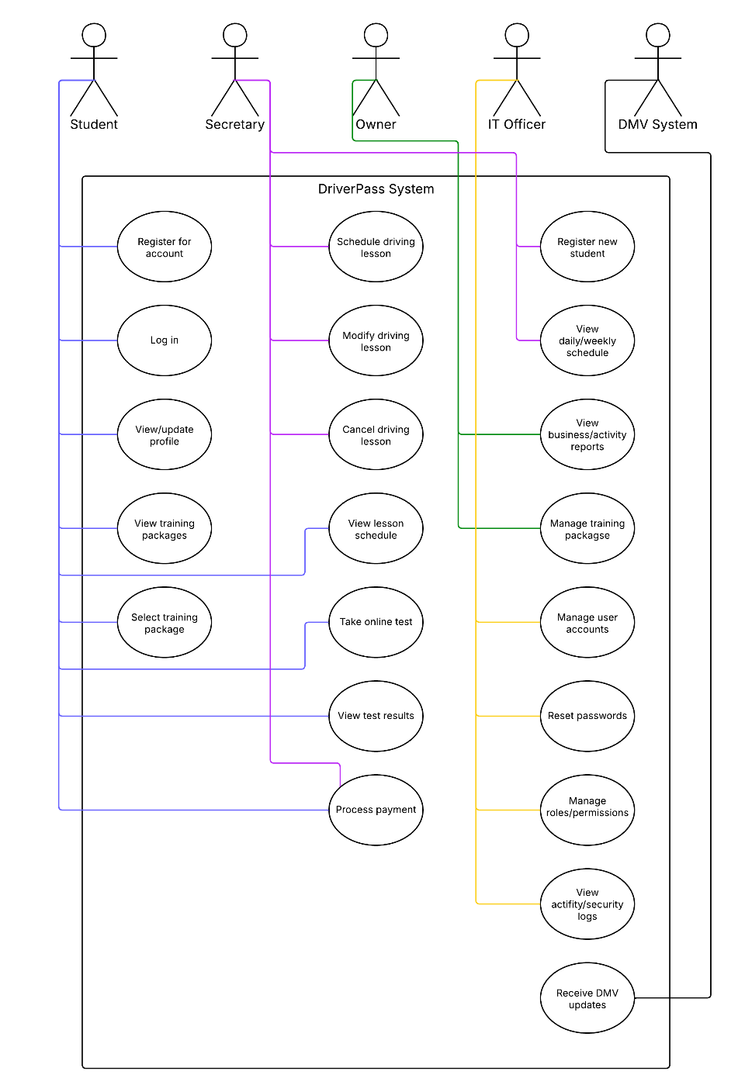

UML Activity Diagrams
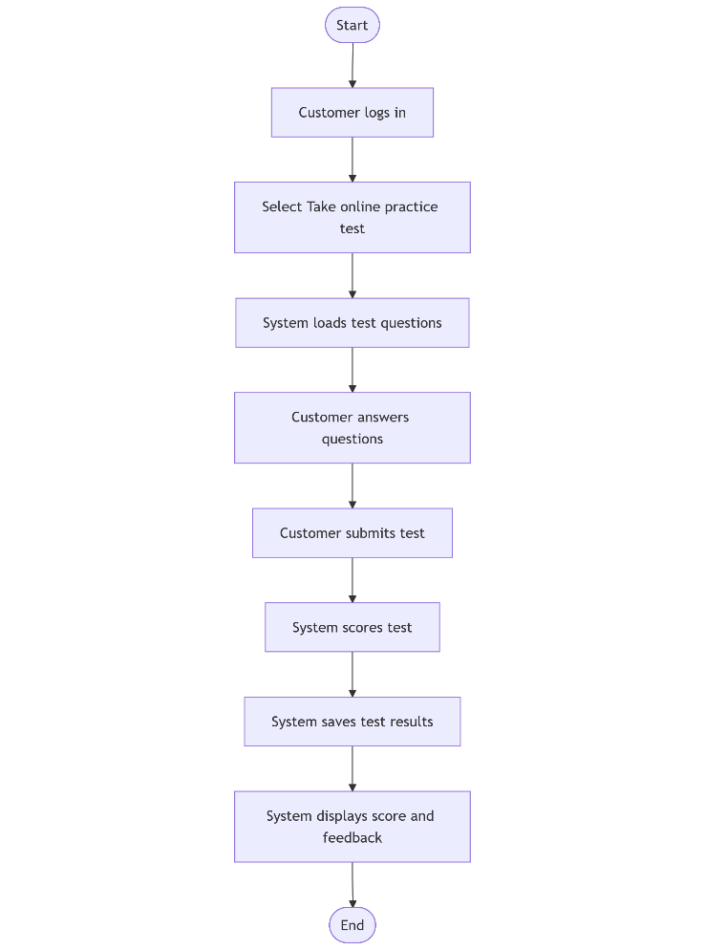
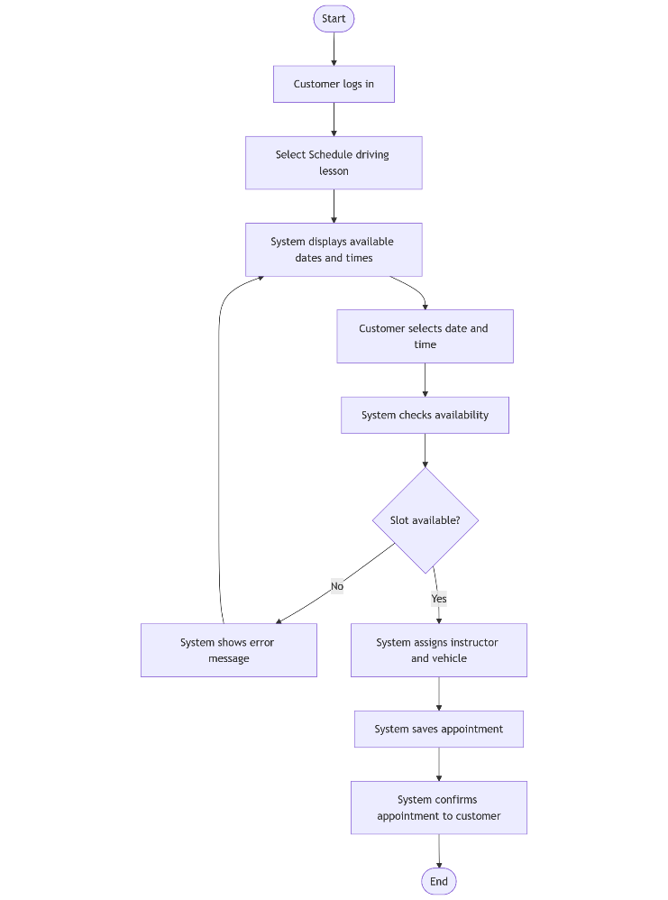

UML Sequence Diagram
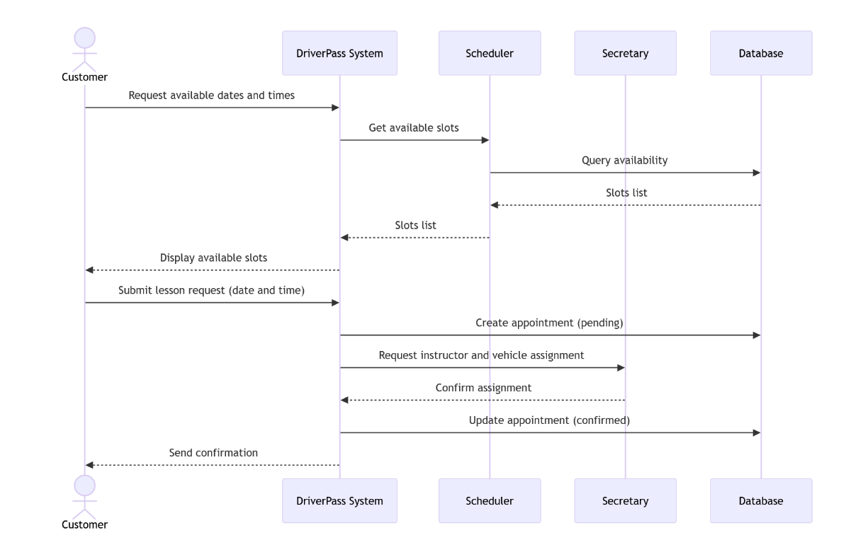

UML Class Diagram
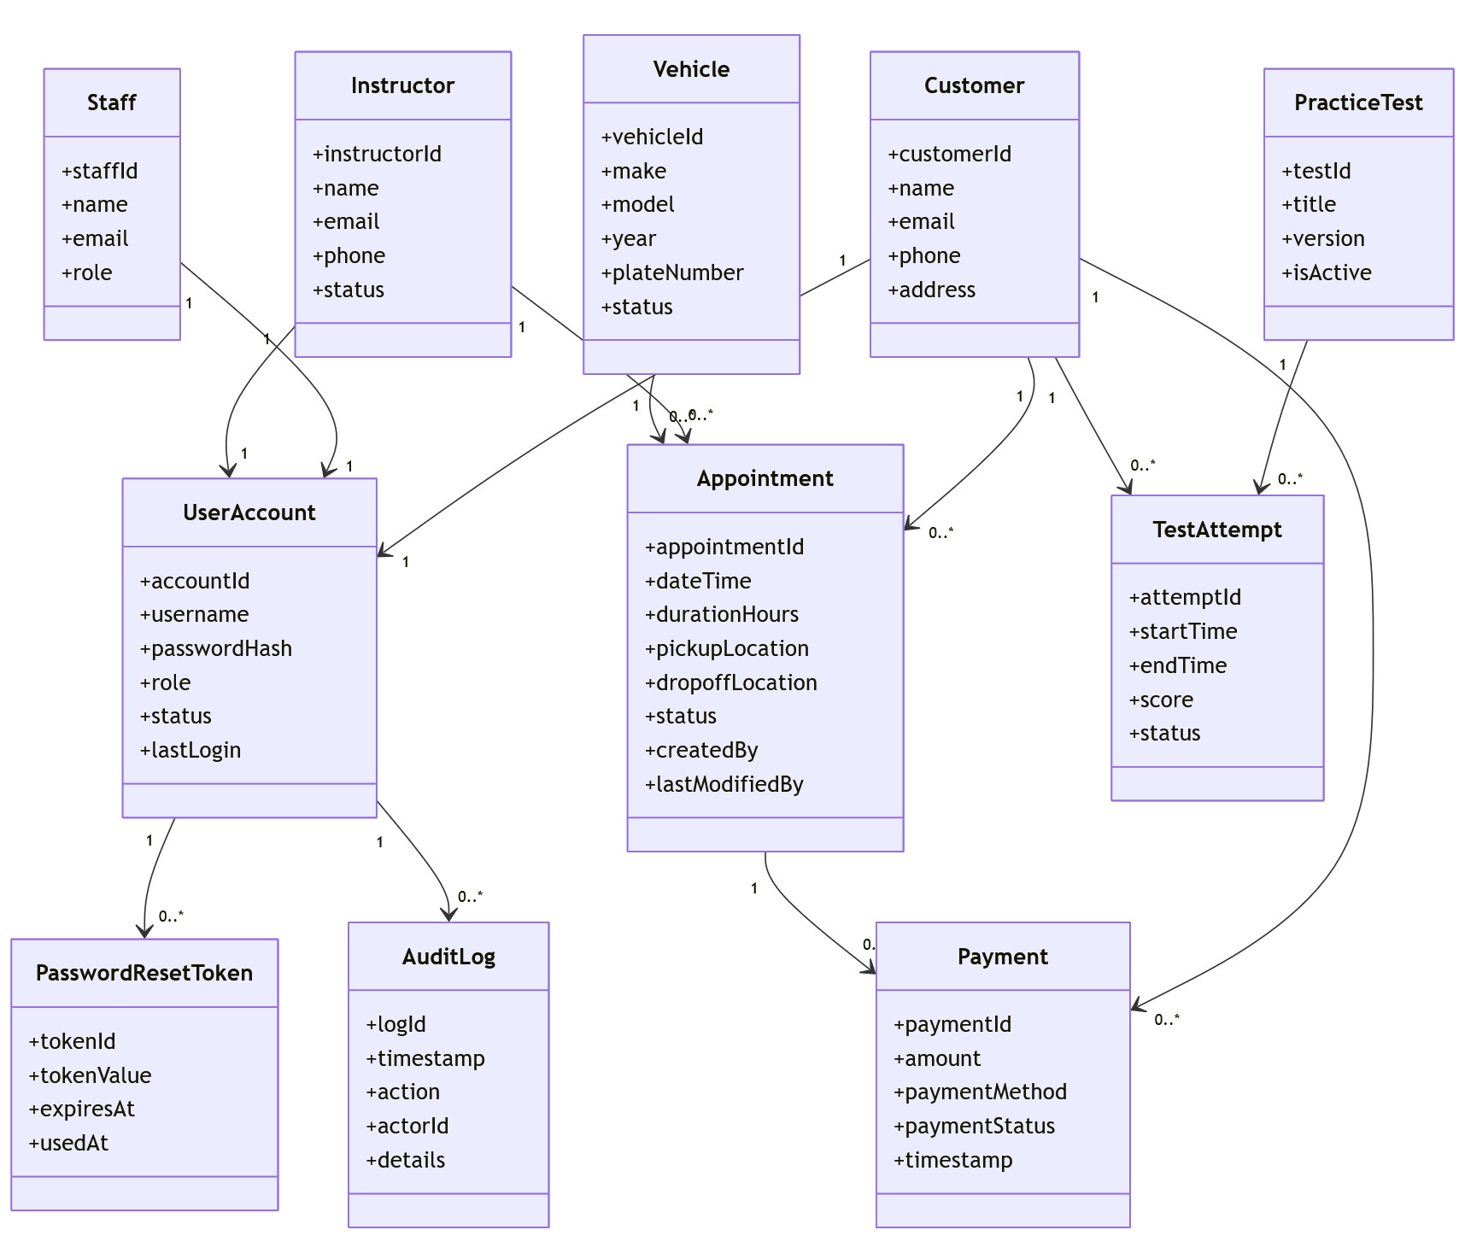

Technical Requirements
DriverPass will be delivered as an online system accessed through a web browser on desktop and mobile devices. Because users need to schedule lessons and take practice tests from different locations, the system will be hosted using cloud-based services rather than local hardware. An active internet connection is required for all system functions.

The system will maintain records for user accounts, lesson appointments, instructors, vehicles, practice tests, and payments in a single database. Sensitive information such as passwords and personal details must be protected when stored and when exchanged with the system. User access will be limited based on role so customers, instructors, staff, and administrators only see and manage appropriate information.

DriverPass must support core features such as logging in, resetting forgotten passwords, scheduling and updating driving lessons, and completing online practice tests. Test results must be scored automatically and saved for later viewing. Lesson scheduling changes must update immediately to avoid double-booking instructors or vehicles. Payments must be recorded accurately and associated with the correct customer and appointment.

Staff and administrative users must be able to manage accounts, assign instructors and vehicles, and review system activity. The system must also support updates to practice test content, including changes based on DMV requirements, without affecting existing schedules or stored data.

